**COCOA RATING PROJECT**

**Introduction**

The project is a case study compiled by Brady Brelinski (founding member of the Manhattan Chocolate Society) aimed at determining the origin of best cocoa beans and countries that produce best chocolate bars.

**Project tool**

Microsoft Excel

**Data cleaning documentation**

* Empty rows and rows of unknown bean origin (Â) were removed.
* The row that its bean origin column has multiple countries was removed as well, therefore a total of 125 rows was removed. Worked with 1670 observations.
* Spelling inconsistencies were fixed.
* The rating was corrected to correspond with the given rating follows; Rating>4.5 = 5, rating>3.75 = 4, 3.75=3.75, rating 3>2.5=3, rating>1.5,2 and rating <1.5=1.
* Some column were renamed while some were added.

**DASHBOARD**

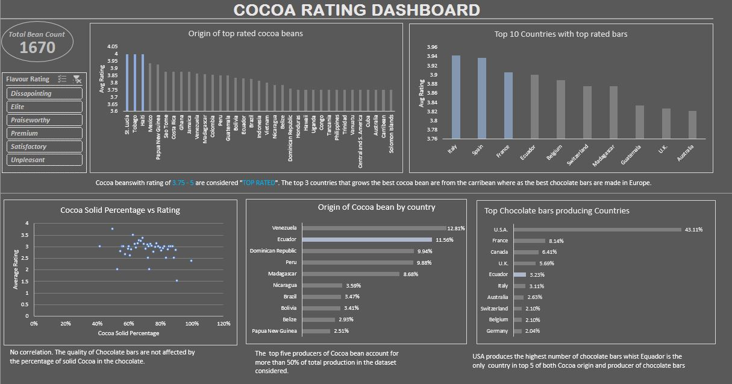

**Analysis**

**NB:** The rating from 3.75 – 5 is considered Top rated for the purpose of this analysis. i.e the best quality.

1. Where are the best cocoa bean grown?

.Analysis shows that the average best cocoa bean was grown St. Lucia, Tobago and Haiti all in the Caribbean with an average rating of 4.0. Venezuela has the single highest rated cocoa bean with an elite rate of 5.0 but the average is below 4.0.

1. Which countries produced the highest rated bars?

Analysis shows that Italy, Spain followed by France has highest rated bars.

1. What is the relationship between cocoa solids percentage and rating?

The quality of chocolate bars is not dependent on the percentage of its Cocoa solids.

**Extras**

1. How the country fared generally regardless of rating

Venezuela and Equador are the highest producer of Cocoa bean accounting for almost 25% while USA is the highest producer of Chocolate bars. Equador is one of the top producers of Cocoa beans as well as chocolate bars.

1. The quantity of each category of rating in the whole dataset.

Only 17% of the Cocoa bean are top rated while the majority are just satisfactory (3.0 rated).